Self-Healing AWS Web App with Free, Local AI Incident Detection
Implementation roadmap — AWS, Linux & networking project
1-week sprint: Thursday 23 July – Thursday 30 July 2026

1. Project overview
This project deploys a small load-balanced web app on a properly segmented AWS VPC, adds an AI-powered anomaly-detection layer that runs entirely on your own EC2 instance (no API key, no per-call cost), and wires the whole thing into an alerting pipeline. It is designed to exercise the three areas you're weakest on — networking and Linux — while adding a current, resume-relevant AI angle without needing a paid model.
Skills exercised:
- Networking (currently your weakest area): VPC design, subnetting, route tables, NAT/Internet gateways, security groups vs. NACLs, load balancing.
- Linux administration: EC2 provisioning, systemd services, Nginx reverse proxy, log rotation, SSH hardening, running a local AI runtime.
- Core AWS services: VPC, EC2, ALB, RDS, CloudWatch, SNS, IAM.
- Applied AI: local, key-free anomaly detection and natural-language incident summarization.

2. Architecture diagram
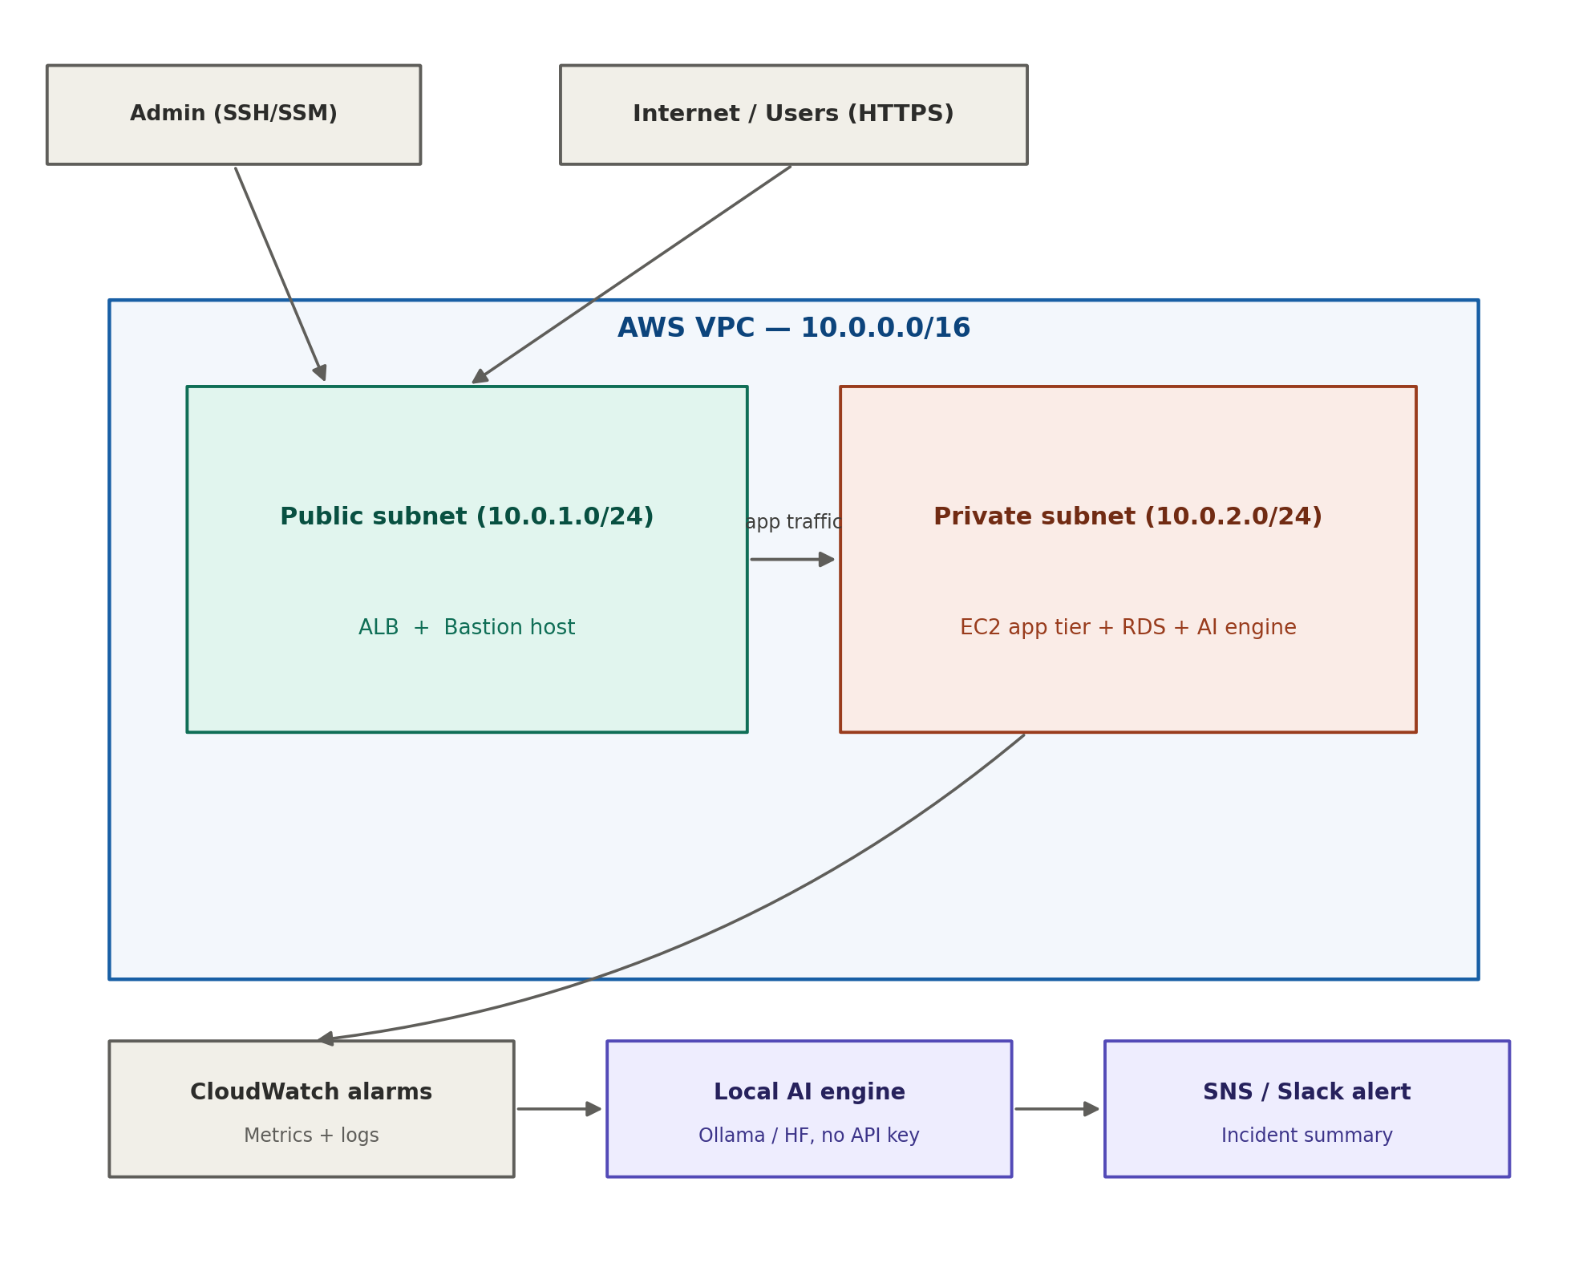
Users hit the Application Load Balancer in the public subnet over HTTPS; admin access goes through the bastion host (or SSM Session Manager). The ALB forwards traffic to the EC2 app tier in the private subnet, which talks to RDS — neither has a public IP. CloudWatch collects metrics and logs from the private subnet; when an alarm fires, a monitoring script calls the local AI engine (running on the same EC2 instance, no external API or key) to turn the raw alarm into a plain-English incident summary, which goes out via SNS or Slack.

3. Service-by-service configuration

3.1 VPC & subnets
- VPC CIDR: 10.0.0.0/16.
- Public subnet: 10.0.1.0/24 (AZ-a) — holds the ALB and bastion host.
- Private subnet: 10.0.2.0/24 (AZ-a) — holds the app EC2 instance and RDS.
- Stretch (for HA practice): mirror both subnets in a second AZ — 10.0.3.0/24 and 10.0.4.0/24.
- Attach an Internet Gateway to the VPC; in the public route table add 0.0.0.0/0 → the IGW.
- Create a NAT Gateway inside the public subnet (needs an Elastic IP); in the private route table add 0.0.0.0/0 → the NAT Gateway.
- Associate each subnet with the correct route table — this step is the one most people forget, and it silently breaks connectivity.

3.2 Security groups & network ACLs
- bastion-sg: inbound 22 from your IP /32 only; all outbound allowed.
- alb-sg: inbound 80/443 from 0.0.0.0/0; outbound restricted to app-sg on port 80.
- app-sg: inbound 80 from alb-sg, inbound 22 from bastion-sg only, inbound 11434 (Ollama) from itself/localhost only — never expose the AI port publicly.
- rds-sg: inbound 3306 (MySQL) or 5432 (Postgres) from app-sg only.
- NACLs: add explicit inbound/outbound rules on both subnets mirroring the security-group intent, numbered with gaps (100, 110, 120…) so you can insert rules later without renumbering.

3.3 Bastion host
- Amazon Linux 2023, t2.micro (free tier eligible).
- Key-pair auth only — disable password authentication in sshd_config.
- Install and configure fail2ban to block repeated failed login attempts.
- Stretch: replace the open SSH port entirely with AWS Systems Manager Session Manager — access is then controlled purely by IAM, and port 22 can stay closed.

3.4 Application Load Balancer
- Internet-facing ALB in the public subnet, across both AZs if you did the HA stretch.
- Target group pointing at the app EC2 instance(s) on port 80, health check path /health.
- Listener on port 80 to start; add port 443 with an ACM certificate if you point a domain at it later.

3.5 EC2 app tier
- Amazon Linux 2023 or Ubuntu, t3.micro to start (see 3.8 for the sizing trade-off if you run a local LLM on this box).
- Nginx as a reverse proxy in front of your app process (Flask, Node, whatever you're most comfortable with).
- The app runs as a systemd unit (Restart=on-failure) so it survives crashes and comes back on reboot.
- A small bash deploy script: pull latest code, restart the systemd service, tail the log to confirm it came up clean.
- CloudWatch agent installed and configured to ship both system metrics and app logs off the box.
- logrotate configured on the app log file so disk usage stays bounded.

3.6 RDS
- MySQL or PostgreSQL, db.t3.micro (free tier eligible for 12 months on a new AWS account).
- Deployed in the private subnet with “Publicly accessible” set to No.
- Security group allows inbound only from app-sg — nothing else, ever.
- Store the DB credentials in AWS Secrets Manager or SSM Parameter Store and have the app fetch them at startup via its IAM role — never hardcode them in app code or a .env file that gets committed.

3.7 CloudWatch
- Alarms on CPUUtilization, ALB 5xx count, and a custom app error-rate metric published from your app.
- A log group receiving app logs via the CloudWatch agent.
- Alarm state changes publish to an SNS topic, which your monitoring script also polls/subscribes to.

3.8 Local AI engine (the “no API key” layer)
This is deliberately not Bedrock, OpenAI, or the Hugging Face Inference API — all three need a key and/or billed access. Instead, a small open-weight model runs directly on the app EC2 instance:
- Install Ollama on the app EC2 instance (or a second small instance if you'd rather keep it separate from the web app).
- Pull a small model sized for the box — Llama 3.2 1B or Phi-3-mini (quantized) are good fits. These need roughly 2–4 GB of RAM, which means a t3.small/t3.medium rather than a free-tier t2.micro (1 GB RAM) — budget a small hourly cost for this one instance, or use the fallback below.
- A Python monitoring script (boto3) polls CloudWatch metrics on a cron schedule; when a threshold is breached, it POSTs the anomaly details to Ollama's local HTTP endpoint (http://localhost:11434/api/generate) and gets back a plain-English summary.
- Fallback if you'd rather not size up the instance: skip the LLM and use a template-based Python function that turns the anomaly numbers into a readable sentence. It's genuinely free, has zero setup risk, and you can document the local-LLM version as a documented next step — the anomaly-detection logic (scikit-learn Isolation Forest or a simple z-score check) is identical either way.
- The generated summary is published to the SNS topic from 3.7 for delivery.

3.9 SNS
- A topic with an email subscription — confirm it via the link AWS emails you.
- Stretch: SNS → a small Lambda → a Slack incoming webhook, for a more “real SRE” feel. Low enough volume that it stays inside the Lambda free tier.

4. AI integration strategy without an API key
The brief was: meaningful AI, no API key, free. Here's how the main options compare:
Option | Needs a key? | Cost | Verdict
Amazon Bedrock | Yes (AWS-billed) | Pay per token | Good service, but fails the “no key / free” requirement.
OpenAI / Anthropic API | Yes | Pay per token | Same issue — excluded.
Hugging Face Inference API | Yes (free tier) | Free, rate-limited | Still needs a token even on the free tier — excluded.
Self-hosted Ollama / transformers on EC2 | No | Only EC2 compute | Chosen approach — fully local, no key, no per-call cost.
Rule-based / template summary | No | Free | Zero-risk fallback if the instance can't fit a model.

Why this matters for the resume: “integrated a third-party AI API” is common on student resumes. “Self-hosted and served an open-weight model for real-time anomaly summarization with no external dependency” is a more specific, more defensible claim — and it's one you can actually explain line-by-line in an interview.

5. Day-by-day task breakdown (23–30 July 2026)
Date | Focus | Tasks | Est. hrs
Thu 23 Jul | Networking foundation | AWS account/IAM check, create VPC, both subnets, IGW, NAT Gateway, route tables and associations | 3–4
Fri 24 Jul | Access control | Security groups, NACLs, launch + harden bastion host, confirm SSH path works end to end | 2–3
Sat 25 Jul | App tier + load balancing | Launch app EC2, install Nginx, deploy app as a systemd service, create ALB + target group + health checks | 3–4
Sun 26 Jul | Data layer | Launch RDS in the private subnet, connect the app to it, move credentials into Secrets Manager / Parameter Store | 2–3
Mon 27 Jul | Observability | Install CloudWatch agent, create alarms, create SNS topic + email subscription, confirm a test alarm fires | 2–3
Tue 28 Jul | AI layer | Install Ollama (or set up the template fallback), build the monitoring/anomaly script, wire CloudWatch → AI → SNS | 3–4
Wed 29 Jul | Testing | Deliberately break things (kill the app process, spike CPU) and confirm alerts fire correctly; fix bugs | 2–3
Thu 30 Jul | Wrap-up | Screenshots/recording of the working system, README + diagram, resume bullets, cost cleanup, push to GitHub | 2–3

6. Do's and don'ts, with reasons

Do
Do | Why
Use least-privilege security groups — only open the exact port you need, from the exact source you need | This is the single most common thing interviewers probe on a cloud resume project.
Put RDS and the app tier in private subnets with no public IP | Matches real production patterns; a database with a public IP is an instant red flag in review.
Use an IAM role on each EC2 instance instead of hardcoded AWS keys | Avoids leaked credentials and is the standard, expected practice.
Tag every resource (Project, Owner, Environment) | Makes cleanup and cost-tracking possible once you have a dozen resources running.
Set a billing alarm before you start | NAT Gateway, RDS, and a larger AI instance all accrue hourly cost — catch a runaway bill early.
Stop or terminate resources at the end of each work session | NAT Gateways and RDS bill by the hour whether you're using them or not.
Commit your setup scripts (not secrets) to GitHub as you go | Commit history is itself evidence of process, which recruiters and interviewers do look at.

Don't
Don't | Why
Open SSH (port 22) to 0.0.0.0/0 anywhere | Instant target for bot scanning; a classic beginner mistake that stands out badly in a demo.
Hardcode DB passwords or tokens in app code or committed files | Gets flagged in any code review; use Secrets Manager or Parameter Store instead.
Attach broad permissions like AdministratorAccess to the app's IAM role | Violates least privilege — expect this exact scenario in an interview question.
Try to run a 7B+ parameter model on a t2.micro/t3.micro | It will run out of memory or be unusably slow; use a 1–3B model or the template fallback instead.
Skip the billing alarm “because it's a small project” | NAT Gateways in particular are the classic surprise-bill source for students on free tier.
Leave RDS or the NAT Gateway running once you're done demoing | These are the two priciest always-on components in this architecture.

7. Cost & cleanup checklist
Take screenshots or a short screen recording of the working system before you tear anything down — you'll want the evidence for your portfolio and resume.
Teardown order (roughly cheapest-risk to most-important-to-kill-first):
- 1. Terminate the app and bastion EC2 instances.
- 2. Delete the RDS instance (skip the final snapshot unless you want to keep it, which also costs money).
- 3. Delete the NAT Gateway, then release its Elastic IP — both bill even when idle.
- 4. Delete the ALB and its target group.
- 5. Leave the VPC, subnets, route tables, security groups, and IAM roles — these are free and you may want to reuse them.
- 6. Double-check the AWS Billing dashboard the next day to confirm nothing is still accruing.

8. Resume & interview talking points
Suggested resume line:
“Deployed a load-balanced, multi-tier web application on a custom AWS VPC with public/private subnet segmentation and least-privilege security groups; built a CloudWatch-triggered monitoring pipeline that uses a self-hosted, key-free open-weight language model to generate plain-English incident summaries delivered via SNS.”
Questions to be ready for:
- “Why private subnet for RDS instead of public?” — be ready to explain the attack-surface reasoning, not just recite the rule.
- “Why self-host the model instead of calling an API?” — cost, no external dependency/key management, and full control over data staying inside your own infrastructure.
- “What would you change for production scale?” — talk about Auto Scaling Groups, multi-AZ RDS, and moving the AI workload off the web-app instance onto its own right-sized box.

